Dr. Head & Partners

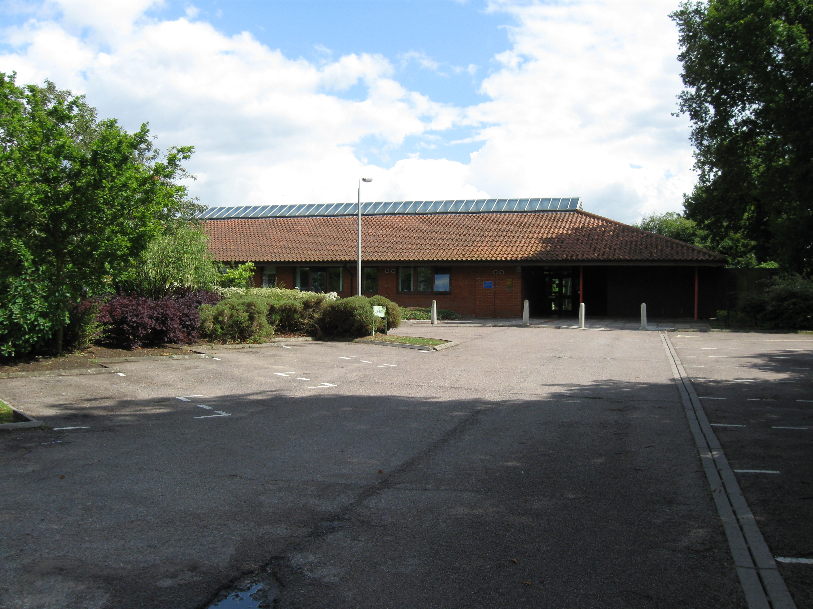

Main Surgery Branch Surgery

The Health Centre Manor Farm Surgery
Chapel Road Church Road
Mendlesham Bacton
Stowmarket Stowmarket
IP14 5SQ IP14 4LJ

Tel: 01449 767722 Tel: 01449 781777
Fax: 01449 766183 Fax: 01449 780371
Dispensary Tel: 01449 767038 Dispensary Tel: 01449 781857

Email:
receptionists@gp-d83019.nhs.uk
dispensary@gp-d83019.nhs.uk
bacton.reception@gp-d83019.nhs.uk
bacton.dispensary@gp-d83019.nhs.uk

Website:
www.mendleshamhealthcentre.co.uk

ABOUT THE PRACTICE

The Practice is long established, serving a rural population in 120 square miles of mid Suffolk. The main surgery is the Health Centre in Mendlesham. In 2003 we opened a new purpose-built branch surgery in Bacton where all 5 Doctors and 4 Nurses consult in rotation.

Inner Area Boundary

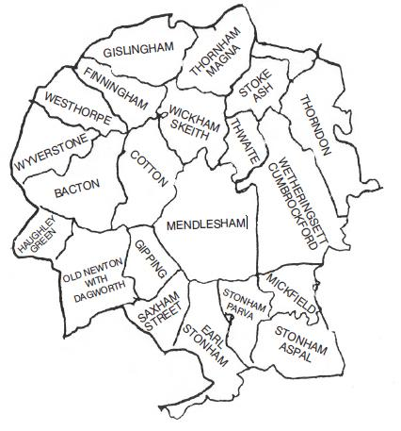

Outer Area Boundary

Our outer area boundary is for existing patients who move a short distance from the inner area boundary to the listed areas below. We are able to retain these patients and continue providing medical services:

Cedars Park, Debenham, Eye, Haughley, Mellis, Occold, Stowupland, Wetherden and Yaxley.

THE DOCTORS

Dr. Paul H. Head
MB. BS. MRCGP.
Qualified The Royal London 1980

Dr. Jonathan M. Herman
MB. BS. MRCGP.
Qualified St. Georges 1989

Dr. Raj Tanna
MB. CHB.MRCGP.
Qualified Unv. of Leicester 1995

Dr. Sarah Evans
BSc. MB. BS. DRCOG. DFFP.
Qualified Unv. of London 1994

Dr. Peter Holloway
MA. MB. BChir
Qualified Cambridge 1983

All Doctors provide full general medical services. Dr. Head has a special interest in western acupuncture. Dr. Herman has a special interest in minor surgery. Dr. Tanna also has a special interest in minor surgery together with ear, nose and throat problems. Dr Evans has a special interest in family planning and female health issues.

ATTACHED STAFF

We have a Midwifery and Counselling Service.

Health Visiting Team can be contacted at either Stowmarket (Tel: 01449 776040) or Eye (Tel: 01379 873782): They are responsible for ongoing support and assessing health needs of all families with children 0 - 5 years old. This includes antenatal visits for first time mothers, child health development assessments and maternal well being. Postnatal groups are held as needed and local ‘Living with Children’ programmes are offered in partnership with Community Education.

District Nurses can be contacted on 0300 123 2425: They visit patients confined to their homes. They undertake nursing assessments and general nursing duties, including wound and continence care, and are involved with the terminally ill. At weekends they share duties with District Nurses attached to Debenham, Eye and Fressingfield surgeries and are contactable through Harmoni out of hour’s service.
To Register

To register as a patient with the Practice please complete forms available from either Mendlesham or Bacton Surgery.

The Practice operates an on-line appointments booking system for the Doctors. Please ask at reception for an information and registration form. Photo ID should be produced for all patients registering for this service.

HOW TO SEE THE DOCTOR

Telephone reception on 01449 767722 (Mendlesham) or 01449 781777 (Bacton) to arrange an appointment. Calls to Bacton are diverted to Mendlesham when Bacton Surgery is closed.

Routine consultations are for 10 minutes. If you feel your appointment may take longer than 10 minutes, please inform reception. You may consult any Doctor; appointments are bookable in advance only. Urgent problems which cannot wait until the next routine appointment may be seen by whichever Doctor is available at the end of morning surgery or before evening surgery. Please let us know if you are unable to attend your booked appointment.

Home visits: We are happy to visit the housebound when appropriate i.e., terminally ill and severely disabled. When possible, please can visit requests be made before 10.30am. Please give our receptionist as much information as possible to help the Doctors assess the urgency of the visit. However, most problems are best dealt with at the surgery.

Telephone calls: If you wish to speak to the Doctor for advice or test results we suggest you try between 11.00 and 11.20am or 14.45 and 15.20pm.

Out of hours: For urgent advice when the surgery is closed please ring 111.

THE PRACTICE STAFF

We employ 30 part-time staff, covering administration, dispensing, reception duties, I.T., secretarial and nursing. Our administration centre is Mendlesham Health Centre.

Practice Manager Mrs. Terri Clare
Assistant Manager Mrs. Debbie Taylor

Nurse Practitioner Mrs. Jan Kelly
Nurse Prescriber Mrs. Alethea Hastings
Practice Nurses Mrs. Katherine Lewis Mrs. Tina Pizzey
Health Care Asst. Mrs. Sharon Easter

Practice Management: Terri Clare is responsible for the running of the Practice and is available for any comments, suggestions and complaints. Our aim is to give you the highest standard of service and deal promptly with any problem that may occur. Terri is supported by Debbie Taylor Assistant Practice Manager who is also available to assist you.

Nurse Practitioners: Have undertaken further study at degree/masters level and are able to see patients for diagnosis, treatment and referral to GPs or secondary care as indicated.

Practice Nurses: Our 3 part-time Practice Nurses, offer comprehensive nursing skills. Alethea Hastings is able to prescribe. Appointments may be booked for dressings, routine and travel vaccinations, ear syringing, coronary heart disease, chronic lung disease and smoking cessation, asthma checks, minor injuries, cervical smears, family planning and well person checks. They also run specialist clinics for diabetes. The Nurses hold clinics at both surgeries every day.

Health Care Assistant: Offers blood tests, ECGs, audiometry, stop smoking service, blood pressure monitoring and assists Doctors with minor surgery.

MENDLESHAM HEALTH CENTRE
OPENING TIMES

Monday – Friday 08.30 - 18.00

DRS’ SURGERY TIMES
Monday 09.00 - 11.00 15.30 - 18.00
Tuesday 09.00 - 11.00 15.30 - 18.00
Wednesday 09.00 - 11.00 15.30 - 18.00
Thursday 09.00 - 11.00 15.30 - 18.00
Friday 08.30 - 11.00 15.30 - 18.00

PRACTICE NURSE SURGERY TIMES
Monday - Friday 08.30 - 12.30 15.00 - 18.00

HEALTH CARE ASSISTANT SURGERY TIMES
Monday - Friday 08.30 - 12.30
Wednesday 03.30 - 06.00

Surgery times may alter to suit demand
MANOR farm SURGERY, BACTON
OPENING TIMES

Monday - Friday 08.30 - 12.30
Monday, Wednesday, Thursday 15.30 - 18.00

DRS’ SURGERY TIMES
Monday 09.00 - 11.00 16.00 - 18.00
Tuesday 09.00 - 11.00
Wednesday 09.00 - 11.00 16.00 - 18.00
Thursday 09.00 - 11.00 16.00 - 18.00
Friday 09.00 - 11.00

PRACTICE NURSE SURGERY TIMES
Monday 09.00 - 12.30 15.30 - 18.00
Tuesday 09.00 - 12.30
Wednesday 09.15 - 12.00 15.30 - 18.00
Thursday 09.15 - 12.00 15.30 - 18.00
Friday 09.15 - 12.00

THE DISPENSARY
OPENING TIMES

Mendlesham: Monday - Friday 08.45 - 12.30
14.30 - 18.00

Bacton Monday - Friday 08.45 - 12.30
Monday, Wednesday, Thursday 15.30 - 18.00

Medication prescribed during your consultation will be dispensed directly for you at the surgery.

Repeat prescriptions: These are authorised by your Doctor once your condition has stabilised. You will be issued with a computer printed repeat slip for a defined period of time before your next review. Only medication listed can be dispensed. If the medication you are requesting is not on your repeat slip, then the dispensers will not be able to issue it until you have been seen or have contacted your Doctor. Normally no medication will be dispensed after the printed review date. Our normal issue is 28 days supply. We cannot accept repeat requests over the telephone: please post, hand in, e-mail or fax your slip. This avoids mistakes. Please give at least 2 working days’ notice and plan ahead for holidays. Our service is only available to patients who live more than 1 mile from a pharmacy.

The Practice operates an on-line repeat prescription request system. Please ask at reception for an information and registration form. Photo ID should be produced for all patients registering for this service.

CLINICS

All times and clinics are correct at time of printing but are subject to availability and occasional alteration.

Antenatal: Thursdays 13.00 - 15.30 at Mendlesham
Run by the Community Midwife. Appointments are made via reception. The Midwife is contactable at Gilchrist Birthing Unit, Eye on 01379 870600.

Well Baby Clinic: 1st & 3rd Thursdays 14.00 - 16.00 at Mendlesham
Run by the Health Visitor. An open clinic for which no appointments are needed giving an opportunity for weighing babies and toddlers, seeing other parents and discussing issues and concerns with the Health Visitor.

Counselling: A specialist counselling service is available through the Practice. Referral is via your Doctor.

Diabetic: Run by Practice Nurse Alethea Hastings. Appointments are sent out from the Health Centre.

Family planning: Routinely with your Doctor, Jan Kelly or Alethea Hastings. Implanon and coil fitting are offered by Dr Evans and Alethea Hastings.
Immunisation: Children’s immunisations are given by the Practice Nurses. Invitations for these will normally be sent out to you. If your child is overdue for immunisation and you have not heard please contact the surgery. Adult immunisations can be arranged with the Nurses at other times. Please make an appointment.

Optomotrist: Visits bi-monthly on Tuesday mornings
Referrals are usually made by Health Visitors and appointments are sent out by Ipswich Hospital Eye Department.

FACILITIES FOR THE DISABLED

Both surgeries have suitable access for disabled patients. There are also hearing aid loops in reception, neck loops available for consultations, access ramps and a disabled toilet.

ABUSE

We ask that you treat the Practice staff with respect. We will not tolerate verbal or physical abuse and will have no hesitation in calling the police if necessary.

SUGGESTIONS BOX

We have a suggestions box in both surgeries. We welcome helpful comments

COMPLAINTS

We operate an inhouse complaints’ procedure. Information about this can be obtained from the Practice staff or, if preferred, please telephone the Practice Manager for a confidential discussion.
.

Friends of Mendlesham Health Centre
(incorporating Bacton Surgery)

We are very grateful to ‘The Friends of Mendlesham Health Centre (incorporating Bacton Surgery)’. This is a charity which exists to channel monies i.e. bequests and proceeds from fund raising, to make purchases to improve the welfare of patients. If you wish to be involved in any way please mention this to our reception staff.
OTHER SERVICES

Asthma: Invitations to see our Practice Nurse are sent out annually.

Coronary Heart Disease: Invitations to attend our review clinics are sent out from the Health Centre.

Travel vaccinations: Please contact reception to collect a questionnaire which needs to be completed at least 8 weeks before departure. You can also complete a questionnaire via our website. Some charges may apply for specific vaccinations.

Cervical smears: Available with the Practice Nurses. Please let the receptionist know when you book your appointment that it is for a cervical smear.

Stop Smoking Service: Provided by the Practice or ring Suffolk Stop Smoking Service direct on Free phone 0800 085 6037.

Minor surgery: By arrangement with your Doctor.

NHS health checks: Those patients eligible will be sent an invitation.

New patient medicals: All newly registered patients over 5 years of age should have a medical check with the Practice Nurse.

Social Services: Available at ’Customer First’ on 08456 023023.

MacMillan Nurse: There is a MacMillan Nurse attached to the Practice.

Community Mental Health Team: Your Doctor may refer relevant problems to this team.

Private medicals: Doctors undertake medicals by appointment. Please ask at reception for details of times and fees.

Hospital transport: The NHS can provide free, non-emergency transport for outpatient appointments to certain patients who are eligible. Please telephone the Patient Transport Clinical Assessment and Advice Centre on 0845 8500774 to book your transport. Lines are open Monday-Friday 8am-6.30pm and Saturday 8am-12 midday. Please have your NHS number, details of your GP surgery and hospital clinic and appointment details to hand. Bookings can be made up to 48 hours in advance of your appointment.

Training: From time to time the Practice will be closed for training. This will usually be for 2 to 3 hours in the afternoon. The times will be notified in advance.

Family carers: The Practice keeps a register of patients who are carers and sends out literature which may help and support them in their caring role. We require written consent from the patient to hold these details. Please let us know if this is applicable to you and if you would like to be included on our Carers’ Register.

CONFIDENTIALITY AND ACCESS TO MEDICAL RECORDS

We ask you for your personal information so that you can receive care and treatment. We keep this information, together with details of your care, because it may be needed if we see you again. We may use some of this information for other reasons: e.g. to help us protect the health of the public generally and to see that the NHS runs efficiently, plans for the future and can account for its actions. Information may also be needed for clinical research. You may be receiving care from other people as well as the NHS. So that we can all work together for your benefit we may need to share some information about you. We only ever use or pass on information about you if people have a genuine need for it in yours and everyone’s interest. The sharing of some types of very sensitive personal information is strictly controlled by law (Data Protection Act 1998). Whenever we can we remove details which identify you. Sometimes the law requires us to pass on information: e.g. to notify a birth. Anyone who receives information from us is under legal duty to keep it confidential. Everyone working for the NHS has a legal duty to keep information about you confidential and you have the right to refuse if you do not want information about you given to others. You have a right of access to your own health record. If applicable, a written request should be made to the Practice Manager.
If at any time you would like to know more about how we use your information, you can speak to your GP or the Practice Manager.

USEFUL TELEPHONE NUMBERS

Ipswich Hospital 01473 712233
West Suffolk Hospital 01284 713000
Norfolk & Norwich Hospital 01603 286286
Gilchrist Birthing Unit, Eye 01379 870600
St. Elizabeth’s Hospice 01473 727776
Sexually Transmitted Diseases (Open Access Hospital Clinic)
01473 711011
Suffolk Patient Services Unit 01473 329000
Citizens Advice Bureau 01449 676060 / 676280
Disabled Advice Bureau 01473 217313
Community Mental Health 01449 774977
Samaritans 01284 750000
Relate 01473 254118
AIDS Helpline 01473 232007
Alcoholics Anonymous 01473 212224
Cruse Bereavement Care 01473 230888
Registrar Births, Deaths & Marriages 01449 612054
Family Planning Clinic 01449 776046
Norfolk Community Alcohol Services (NORCAS) 01473 259382
Emergency dental service 0800 389 6819
Out of Hours Service 111
Suffolk NHS 01473 770000
PALS (Patient Advice & Liaison Service) 0800 389 6819
POHWER ICAS 0845 456 1084
People of Herfordshire Want Equal Rights
Independent Complaints Advocacy Service
(Suffolk Area)

PATIENT PARTICIPATION GROUP

Changes to the General Medical Services' contract for 2011/12 require Practices to promote proactive engagement with patients through the use of effective Patient Reference Groups (PRGs), and to seek views from the Practice patients via patient surveys. We are required to:

- Agree areas of priority

- Collate patient views through surveys

- Agree an action plan with our Patient Reference Group

- Publicise the results of the surveys

- Publicise the actions we have taken and what is achieved as a result.

Our PRG will help interpret patient survey feedback, stimulate discussion and plan change as a result. Monitoring and re-surveying of patients will establish if improvement is evident.

You could become a Member of our PRG
To help us with this, we are setting up a virtual patient representation group so that you can have your say. We will ask the members of this representative group some questions from time to time, such as what you think about our opening times or the quality of the care or service you received. We will contact you via email and keep our surveys succinct so it should not take too much of your time.

We seek to represent the views of the Practice population as fully as possible with people of different ages, gender and race; people who are working and retired; people who have sensory impairment; people with long-term conditions i.e. diabetes, heart or respiratory disease; people who are disabled or able-bodied.

If you would like to join our PRG, please go to the "Contact Us" page on our website http://www.mendleshamhealthcentre.co.uk/ or pick up a form from our reception or telephone the Practice Manager on 01449 767722.

For more general information about Patient Reference Groups visit the website of the National Association of Patient Participation http://www.napp.org.uk/

